Assignment-4-May-2022

1. **Write the steps to create an windows ec2 server.**

1.Open EC2 and click on launch instances.

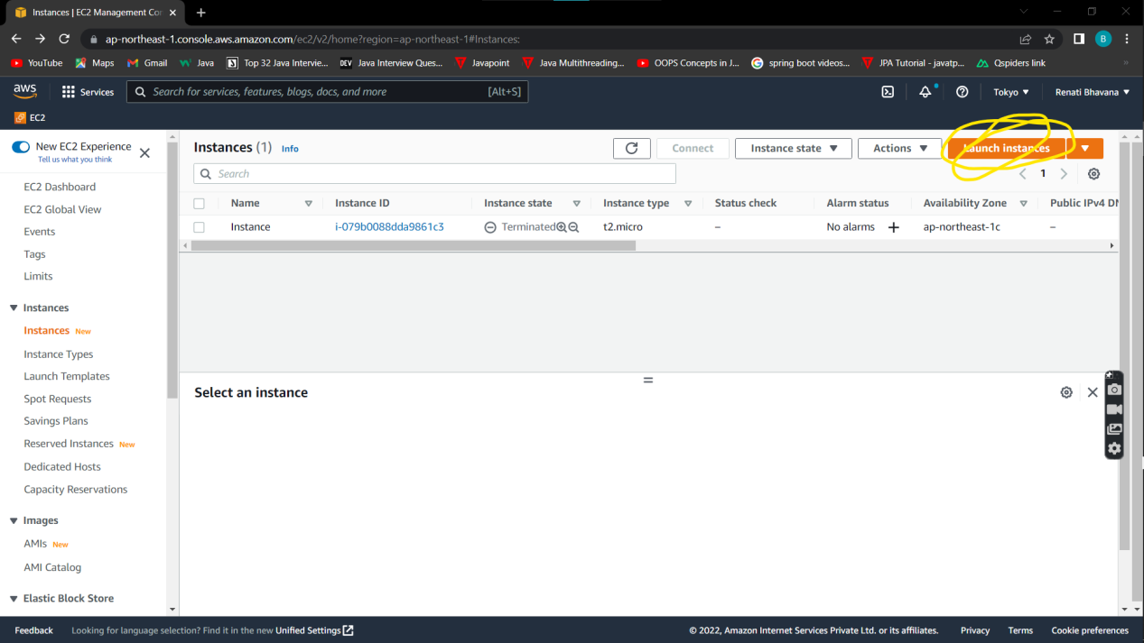

1. Provide some name and choose windows from AMI. And make sure free tier one.

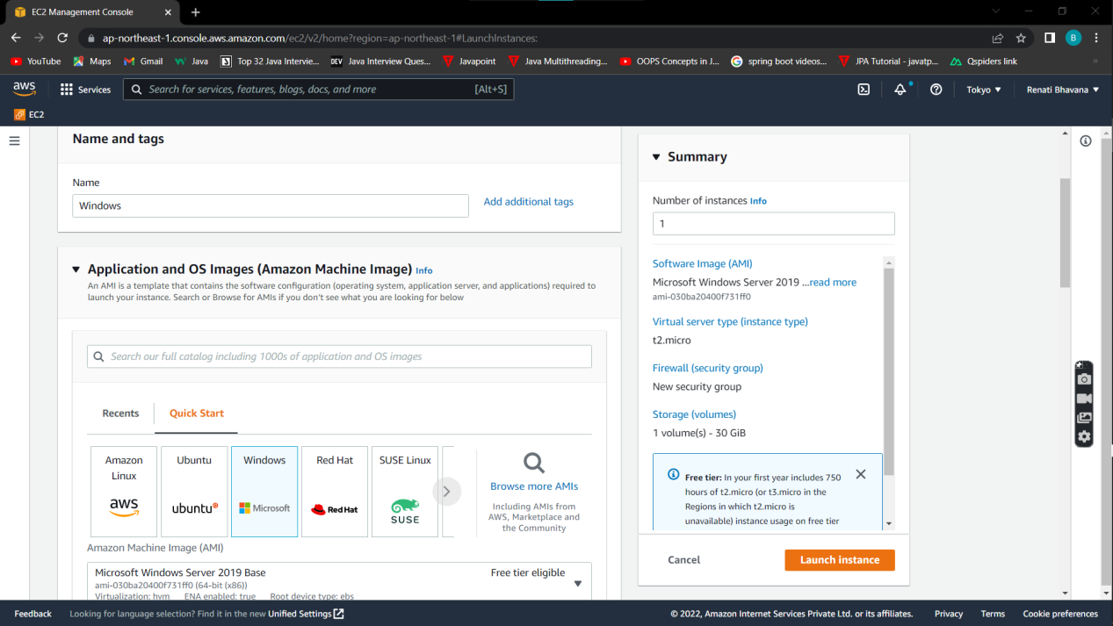

1. Choose the KP and click on launch instance .

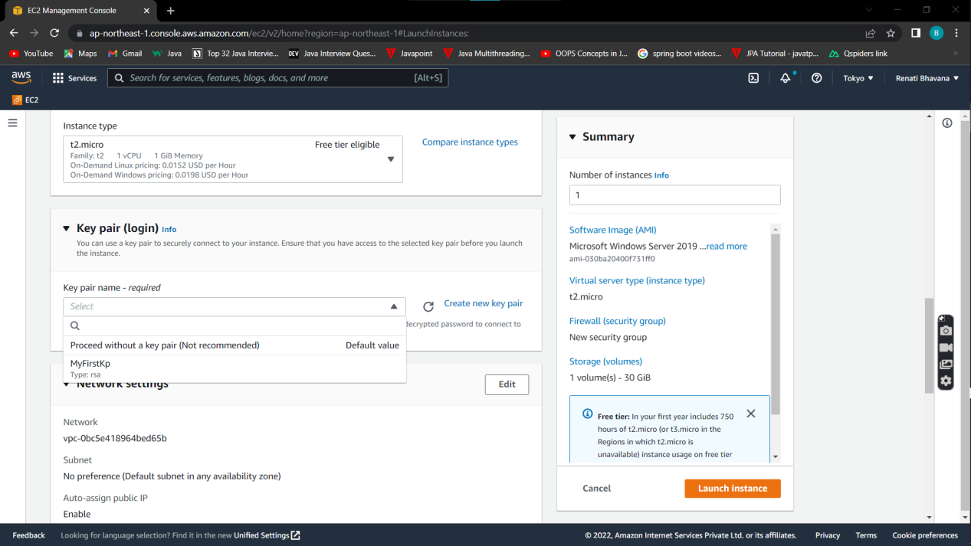

1. Successfully created a instance.

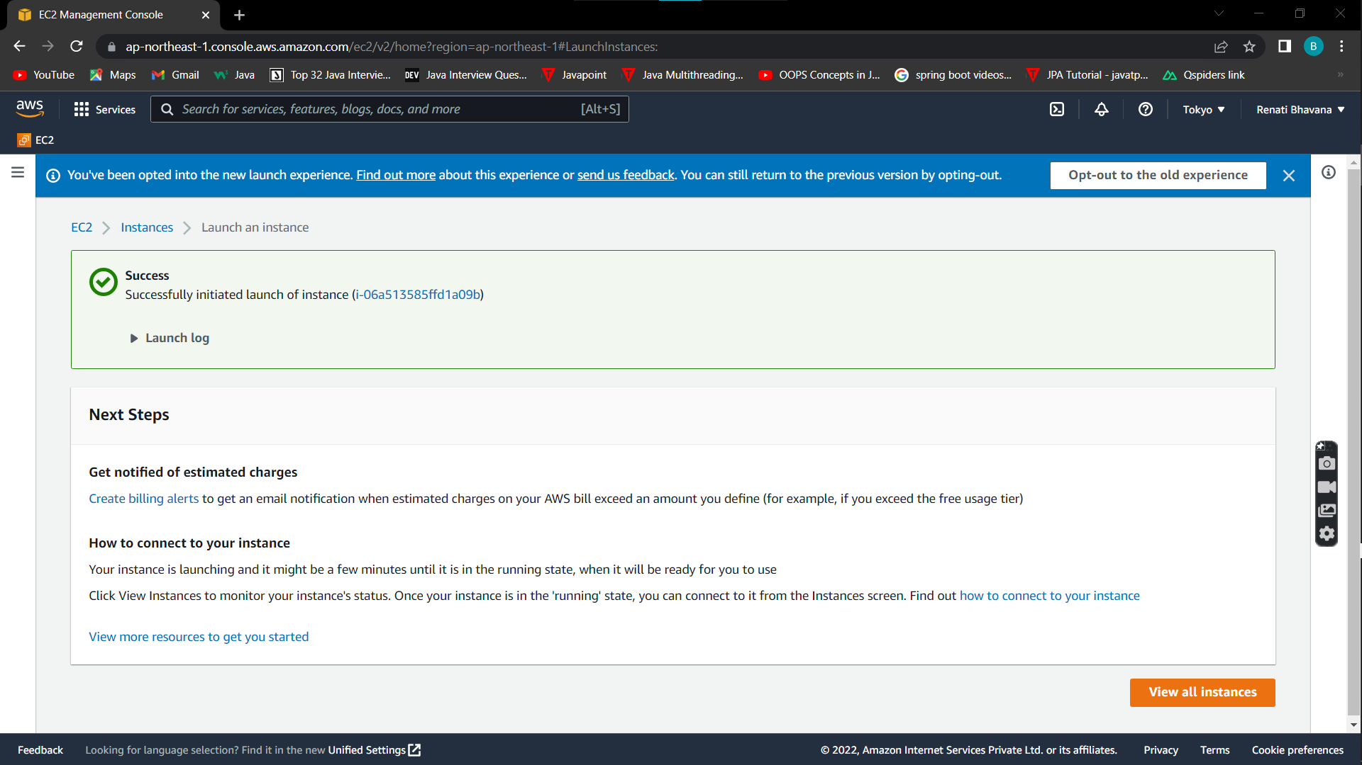

1. **Write the steps to connect to windows ec2 server from a windows machine?**

Steps to connect:

1. Click on the created instance and connect it.

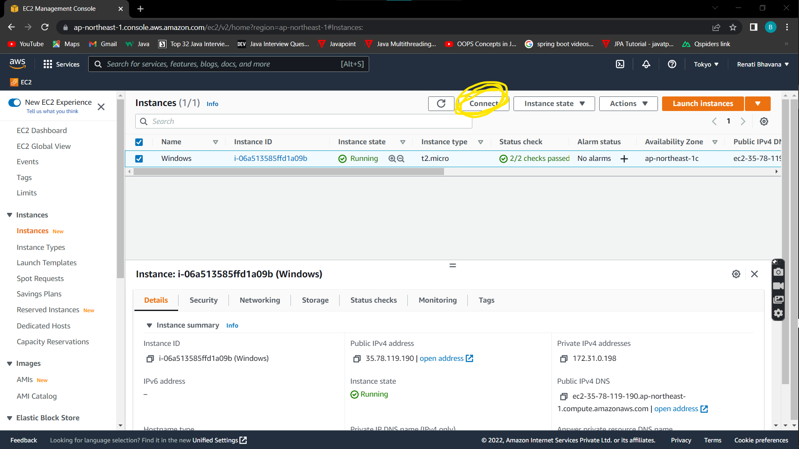

1. You will navigate to this page click on RDP client and Download remote desktop file .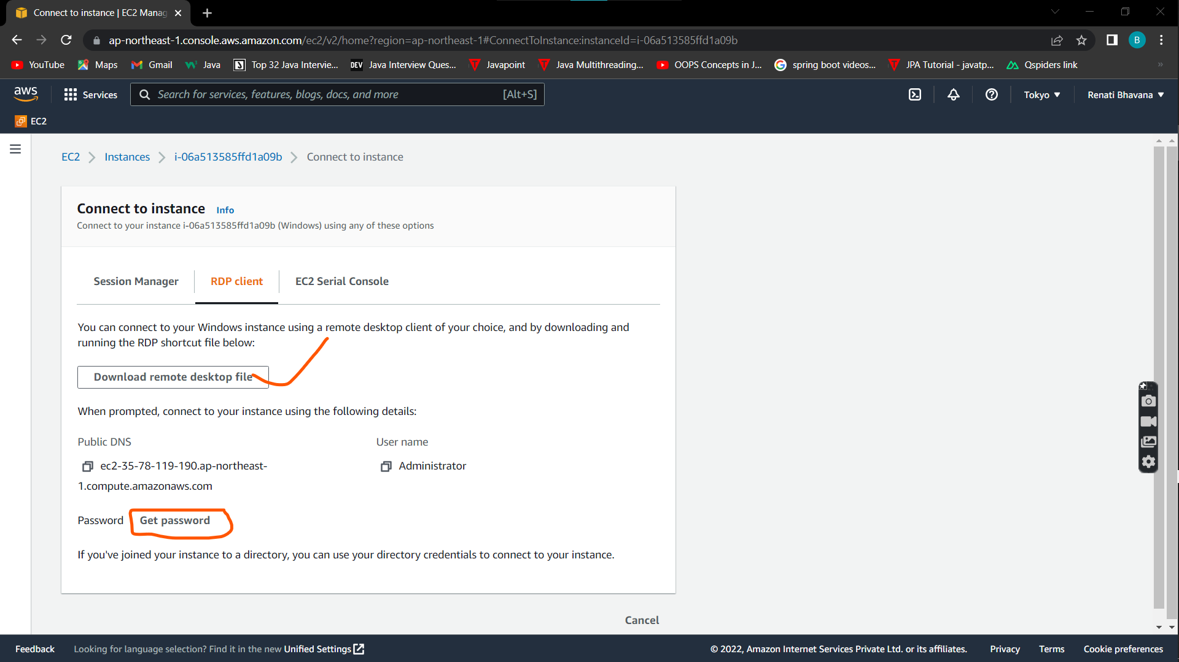3.click o get password and browse the password from u r local and click on decrypt password and save that password in a secure place.

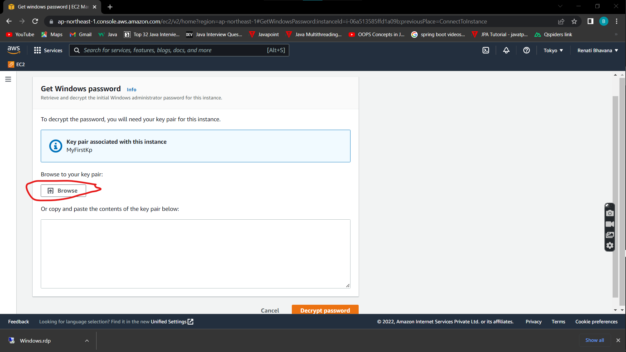

4.Now open the downloaded remote desktop file and click on connect and provide password which u saved.and click on ok and continue..

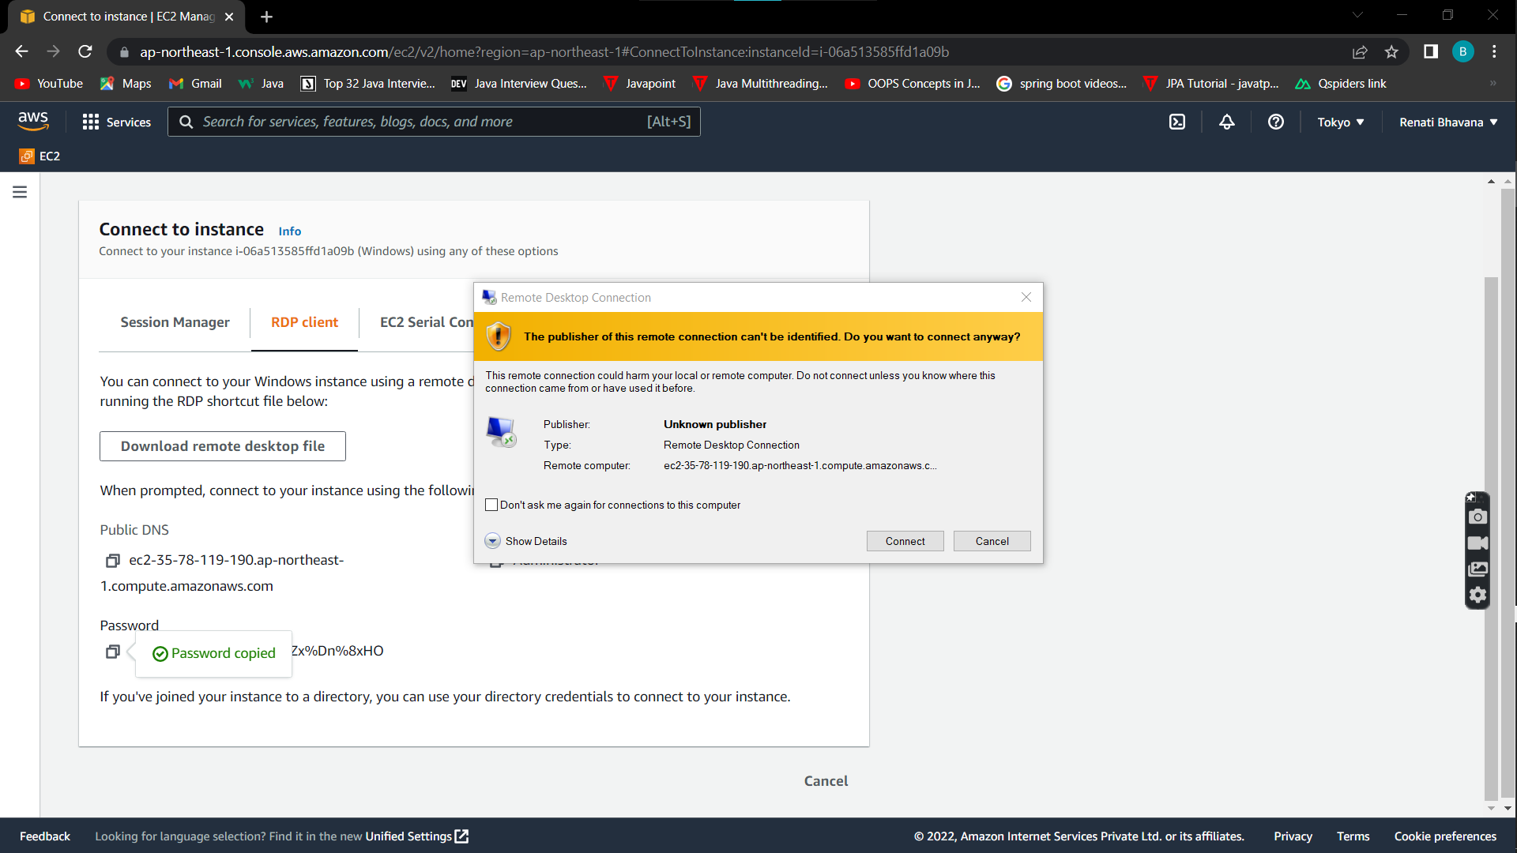

5.The connection is ready.Here we go….



1. **What the different types of Accessing services? Explain**

There are 2 types :

1. **Through Access key (Credentials).**

Suppose we are having IAM user and we attached some policies which contains permissions for that user and if we want to connect from EC2 instance to S3 bucket…..This happens through IAM user only.

EC2 have AWS CLI with Access Key through which policies will be gained. And from their users will get and will connect to S3 instance … This is not secure as the credentials are stored in EC2 instance that may hack by some other members.

1. **IAM Role**.

Here we will create IAL role and will attech policies which are required to it and we will attach this IAM role in EC2 instance and from here we can access the S3 instance .Here no credentials are stored and it is secured one.